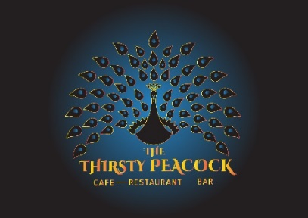

**Dinner Menu**

**From 5 PM Onwards**

**STARTERS**

**Garlic Exotica Bread, Garlic Butter, Mix Salsa, Cheese $18.00**

**Warmed Olives, Olive Oil, Feta, Parmesan House Bread $18.00**

**Seasonal Soup *served with Bread (Gluten free bread available)* $18.00**

**Lemon Pepper Squid, Asian Slaw, Lemon, Tartar (GF) $22.00**

**Bombay Fried Chicken, TTP Slaw, Coriander, Mint Chutney (GF) $23.00**

**Amritsari Fish, Asian Slaw, Mint Chutney (GF) $23.00**

**Pork Bites, Braised Cabbage, Char Sui Sauce (GF) $20.00**

**Ginger & Prawn Dumplings served with Nuoc Cham Sauce and Chilli Sauce (x5) $22.00**

**Cumin Cauliflower, Pumpkin Puree, TTP Slaw (V) (GF) $21.00**

**Thyme Garlic Polenta Fries with Chutney $16.00**

**MAINS**

**Teriyaki Pork Belly, Braised Cabbage, Duck Fat Potato, Apple Stick, Pea Puree (GF) $44.00**

**Pan Seared Market Fish, Seasonal Vegetables, Cherry Tomato, Vegetable Mash,**

**Chimichurri, Italian Lemon (GF) $44.00**

**Lamb Rump, Pumpkin Puree, Duck fat Potatoes, Green Beans, Pickled Radish,**

**Cumin Labneh, Red Wine Jus (GF) $48.00**

**Confit Duck, Red Wine reduction, Melange of Seasonal Vegetables,**

**Potato Rosti (GF) (DF) $ 46.00**

**Pea Risotto, Green Beans, Parmesan Cheese, Herb Oil, Baby Spinach, Micro Herbs (GF) $41.00**

**14 days Aged Beef Fillet, Broccoli Mash, Seasonal Vegetables, Red Wine Jus (GF) $46.00**

**TTP Sea food Risotto, Herb Oil, Parmesan Cheese, Micro Herbs (GF) *$*46.00**

**Slow Roasted Malabar Beef Cheek, Mustard Mash, Beans and Broccoli,**

**Fried Shallots and Peanuts (DF,GF) $46.00**

**Fresh Green Garden Salad $12.00**

**Seasonal Vegetables with Sliced Almonds $14.00**

**Duck Fat Herb Potato $10.50**

**DESSERTS**

**Crème Brulé, Short Bread, Seasonal Fruit Compote $22.00**

**Chocolate Cake, Chocolate Sauce, Berry Yoghurt, Chocolate Ice-Cream $21.00**

**Apple Crumble Tart, Salted Caramel Ice-Cream $20.00**

**Cheesecake, House Yogurt, Blood Orange, Mint $22.00**

**Affogato, House Vanilla Bean Ice cream, Espresso $14.00 (with Liqueur) $20.00**

**Duo of Artisanal Cheese, Gourmet Crackers**, **Pickles, Onion & Fig Chutney $28.00**